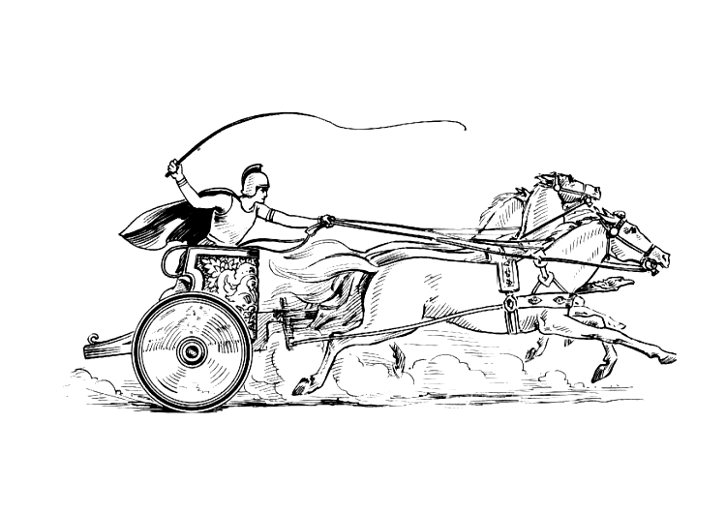Manduessedum - Mancetter Village (Place of War Chariots)
Mancetter Parish Council
Serving the People of Mancetter and Ridge Lane

You are invited to the Mancetter Parish Council Meeting
being held in the Schoolroom of St Peter’s Church Mancetter
on Tuesday 23rd September 2025 at 7pm.

AGENDA

- Welcome and Apologies.

- Chairman’s request that anyone recording the meeting make themselves known, to allow
for openness and recognise practicalities. An audio recording of the meeting will be
made by the Council, and will be deleted upon production of the draft minutes.

- Declared Notice of Interest by Councillors concerning Agenda items.

- Public Question time of up to 15 Minutes for Parishioners to raise issues.

- Police, County and Borough Councillor feedback.

- Minutes of the last meeting.

- To accept the draft minutes of the Parish Council Meeting held on 22nd July 2025.

- Matters Arising from the meeting on 22nd July 2025

- To facilitate improved Councillor communication and updates between meetings, the
council is asked to consider holding an informal “Councillor Catch Up” session on a Thursday Morning between 10am and 11am at Mancetter Memorial Hall on a pre-arranged date in February, June, August, October and December. (16th October ?)

- Finance

- Signing of all payments in accordance with standing orders, financial regulations and the bank mandate.
- To approve the cost of an 8 cubic metre skip with tailgate for the allotment site.

- Local Government Devolution Feedback

- To respond to the Town and Parish Council survey on Devolution and Local Government re-organisation. Deadline 26th September at 5pm.
This short survey was developed following feedback from the engagement session held on the 8th of July, in collaboration with District and Borough Council partners. It aims to gather further views from Town and Parish Councils, and Parish Meetings, to help shape proposals for Local Government Reorganisation and Devolution, which are due for submission in November 2025.

The survey should take no more than 15 minutes to complete, and your input will be invaluable in informing future governance and partnership arrangements.

We are collecting only basic contact details (name, phone number, and email), which may be shared with participating councils solely for the purpose of considering responses. All data will be handled securely and in line with data protection legislation.

Click here to complete the survey

- Feedback from Focus group Meetings re Devolution and Teams briefing on 4th September 2025.

11 Cemetery and Maintenance around the Parish

- To consider a community planting project for Parish Council green spaces.
- To review the contract requirements for managing the needs of the council.
- Update on contract work for digitalising cemetery records.
- To determine a proposal for a bench in Mancetter Cemetery.

- Planning Matters and New Applications since the previous meeting

- Update on Approved, Rejected, Pending Applications, Enforcement Issues and Appeals.

PAP/2024/0154 & 0160 Greenacres, Nuneaton Road Mancetter - Pending
PAP/2024/0186 Kirby Glebe Farm, Atherstone Road, Hartshill - Pending
NWB/24CM013 Tarmac Quarry County Council Minerals Application- Pending
PAP/2024/0538 Barn Fishery Atherstone Road Hartshill - Pending
PAP/2025/0336 Chase Cottage Purley Chase Lane – Removal of Sycamore Tree - Granted

CMP/2025/00072 Signage relating to hot food van Manor Road Mancetter
CMP/2025/00078 Siting of Hot Food Van. – Application withdrawn

- To discuss any new applications received.
- Update on Neighbourhood planning, including the creation of a Local Nature Action Plan.

13 Date of next meeting- Tuesday 25th November 2025 7pm at St Peter’s Church schoolroom.

Signed 
Date 18th September 2025.
Elane Higgins
Parish Clerk Mancetter Memorial Hall Old Farm Road Mancetter CV9 1QN
Tel: 01827 722552 / 07368 265051
Email: parishclerk@mancetterparishcouncil.gov.uk
Website: www.mancetterparishcouncil.gov.uk

